HOW DECISION TREE ALGORITHM WORKS
Source: https://dataaspirant.com/2017/01/30/how-decision-tree-algorithm-works/

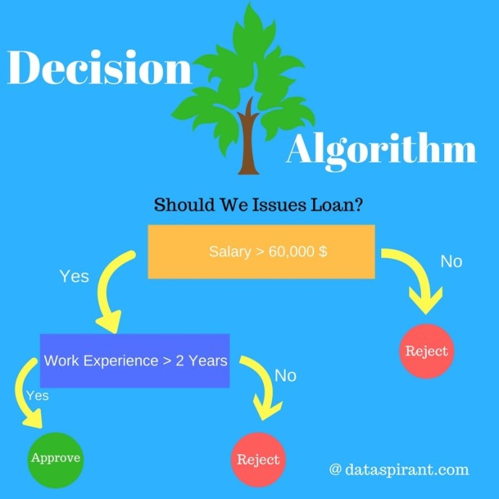
Decision Tree Algorithm

Introduction to Decision Tree Algorithm
Decision Tree algorithm belongs to the family of supervised learning algorithms. Unlike other supervised learning algorithms, decision tree algorithm can be used for solving regression and classification problems too.
The general motive of using Decision Tree is to create a training model which can use to predict class or value of target variables by learning decision rules inferred from prior data(training data).
The understanding level of Decision Trees algorithm is so easy compared with other classification algorithms. The decision tree algorithm tries to solve the problem, by using tree representation. Each internal node of the tree corresponds to an attribute, and each leaf node corresponds to a class label.

Decision Tree Algorithm Pseudo code
- Place the best attribute of the dataset at the root of the tree.
- Split the training set into subsets. Subsets should be made in such a way that each subset contains data with the same value for an attribute.
- Repeat step 1 and step 2 on each subset until you find leaf nodes in all the branches of the tree.
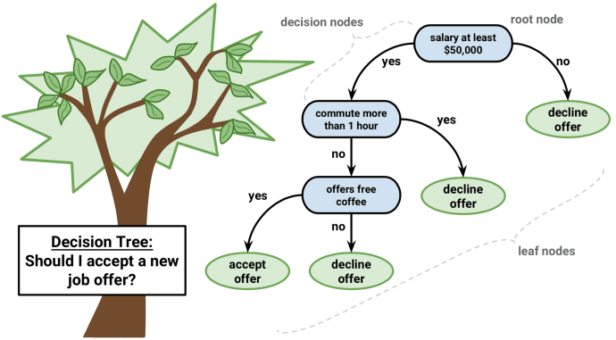
Decision Tree classifier, Image credit: www.packtpub.com
In decision trees, for predicting a class label for a record we start from the root of the tree. We compare the values of the root attribute with record’s attribute. On the basis of comparison, we follow the branch corresponding to that value and jump to the next node.
We continue comparing our record’s attribute values with other internal nodes of the tree until we reach a leaf node with predicted class value. As we know how the modeled decision tree can be used to predict the target class or the value. Now let’s understanding how we can create the decision tree model.

Assumptions while creating Decision Tree
The below are the some of the assumptions we make while using Decision tree:
- At the beginning, the whole training set is considered as the root.
- Feature values are preferred to be categorical. If the values are continuous then they are discretized prior to building the model.
- Records are distributed recursively on the basis of attribute values.
- Order to placing attributes as root or internal node of the tree is done by using some statistical approach.
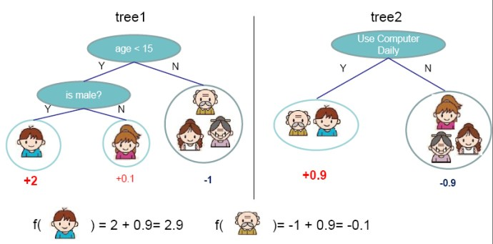
Decision tree model example Image Credit: http://zhanpengfang.github.io/
Decision Trees follow Sum of Product (SOP) representation. For the above images, you can see how we can predict can we accept the new job offer? And Use computer daily? From traversing for the root node to the leaf node.
It’s a sum of product representation. The Sum of product (SOP) is also known as Disjunctive Normal Form. For a class, every branch from the root of the tree to a leaf node having the same class is a conjunction (product) of values, different branches ending in that class form a disjunction (sum).
The primary challenge in the decision tree implementation is to identify which attributes we need to consider as the root node and each level. Handling this is know the attributes selection. We have different attributes selection measure to identify the attribute which can be considered as the root note at each level.
The popular attribute selection measures:
- Information gain
- Gini index

Attributes Selection
If dataset consists of “n” attributes then deciding which attribute to place at the root or at different levels of the tree as internal nodes is a complicated step. By just randomly selecting any node to be the root can’t solve the issue. If we follow a random approach, it may give us bad results with low accuracy.
For solving this attribute selection problem, researchers worked and devised some solutions. They suggested using some criterion like information gain, gini index, etc. These criterions will calculate values for every attribute. The values are sorted, and attributes are placed in the tree by following the order i.e., the attribute with a high value (in case of information gain) is placed at the root.
While using information Gain as a criterion, we assume attributes to be categorical, and for gini index, attributes are assumed to be continuous.

Information Gain
By using information gain as a criterion, we try to estimate the information contained by each attribute. We are going to use some points deducted from information theory.
To measure the randomness or uncertainty of a random variable X is defined by Entropy.
For a binary classification problem with only two classes, positive and negative class.
- If all examples are positive or all are negative then entropy will be zero i.e, low.
- If half of the records are of positive class and half are of negative class then entropy is one i.e, high.
By calculating entropy measure of each attribute we can calculate their information gain. Information Gain calculates the expected reduction in entropy due to sorting on the attribute. Information gain can be calculated.
To get a clear understanding of calculating information gain & entropy, we will try to implement it on a sample data.

Example: Construct a Decision Tree by using “information gain” as a criterion
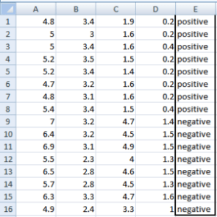
We are going to use this data sample. Let’s try to use information gain as a criterion. Here, we have 5 columns out of which 4 columns have continuous data and 5th column consists of class labels.
A, B, C, D attributes can be considered as predictors and E column class labels can be considered as a target variable. For constructing a decision tree from this data, we have to convert continuous data into categorical data.
We have chosen some random values to categorize each attribute:
A | B | C | D
>= 5 | >= 3.0 | >= 4.2 | >= 1.4
< 5 | < 3.0 | < 4.2 | < 1.4

There are 2 steps for calculating information gain for each attribute:
- Calculate entropy of Target.
- Entropy for every attribute A, B, C, D needs to be calculated. Using information gain formula we will subtract this entropy from the entropy of target. The result is Information Gain.
The entropy of Target: We have 8 records with negative class and 8 records with positive class. So, we can directly estimate the entropy of target as 1.
Variable E
Positive | Negative
8 | 8
Calculating entropy using formula:
E(8,8) = -1*( (p(+ve)*log( p(+ve)) + (p(-ve)*log( p(-ve)) )
= -1*( (8/16)*log₂(8/16)) + (8/16) * log₂(8/16) )
= 1

Information gain for Var A
Var A has value >=5 for 12 records out of 16 and 4 records with value <5 value.
- For Var A >= 5 & class == positive: 5/12
- For Var A >= 5 & class == negative: 7/12
  - Entropy(5,7) = -1 * ( (5/12)*log2(5/12) + (7/12)*log2(7/12)) = 0.9799
- For Var A <5 & class == positive: 3/4
- For Var A <5 & class == negative: 1/4
  - Entropy(3,1) = -1 * ( (3/4)*log2(3/4) + (1/4)*log2(1/4)) = 0.81128
Entropy(Target, A) = P(>=5) * E(5,7) + P(<5) * E(3,1)
= (12/16) * 0.9799 + (4/16) * 0.81128 = 0.937745

Information gain for Var B
Var B has value >=3 for 12 records out of 16 and 4 records with value <5 value.
- For Var B >= 3 & class == positive: 8/12
- For Var B >= 3 & class == negative: 4/12
  - Entropy(8,4) = -1 * ( (8/12)*log2(8/12) + (4/12)*log2(4/12)) = 0.39054
- For Var B <3 & class == positive: 0/4
- For Var B <3 & class == negative: 4/4
  - Entropy(0,4) = -1 * ( (0/4)*log2(0/4) + (4/4)*log2(4/4)) = 0
Entropy (Target, B) = P(>=3) * E(8, 4) + P(<3) * E(0, 4)
= (12/16) * 0.39054 + (4/16) * 0 = 0.292905

Information gain for Var C
Var C has value >=4.2 for 6 records out of 16 and 10 records with value <4.2 value.
- For Var C >= 4.2 & class == positive: 0/6
- For Var C >= 4.2 & class == negative: 6/6
  - Entropy(0,6) = 0
- For VarC < 4.2 & class == positive: 8/10
- For Var C < 4.2 & class == negative: 2/10
  - Entropy(8,2) = 0.72193
Entropy (Target, C) = P (>=4.2) * E (0, 6) + P (< 4.2) * E (8, 2)
= (6/16) * 0 + (10/16) * 0.72193 = 0.4512

Information gain for Var D
Var D has value >=1.4 for 5 records out of 16 and 11 records with value <5 value.
- For Var D >= 1.4 & class == positive: 0/5
- For Var D >= 1.4 & class == negative: 5/5
  - Entropy(0,5) = 0
- For Var D < 1.4 & class == positive: 8/11
- For Var D < 14 & class == negative: 3/11
  - Entropy(8,3) = -1 * ( (8/11)*log2(8/11) + (3/11)*log2(3/11)) = 0.84532
Entropy(Target, D) = P(>=1.4) * E(0,5) + P(< 1.4) * E(8,3)
= 5/16 * 0 + (11/16) * 0.84532 = 0.5811575
Target  Positive Negative  A >= 5.0 5 7  <5 3 1  Information Gain of A = 0.062255 | Target  Positive Negative  B >= 3.0 8 4  < 3.0 0 4  Information Gain of B= 0.7070795
Target  Positive Negative  C >= 4.2 0 6  < 4.2 8 2  Information Gain of C= 0.5488 | Target  Positive Negative  D >= 1.4 0 5  < 1.4 8 3  Information Gain of D= 0.41189
From the above Information Gain calculations, we can build a decision tree. We should place the attributes on the tree according to their values.
An Attribute with better value than other should position as root and A branch with entropy 0 should be converted to a leaf node. A branch with entropy more than 0 needs further splitting.
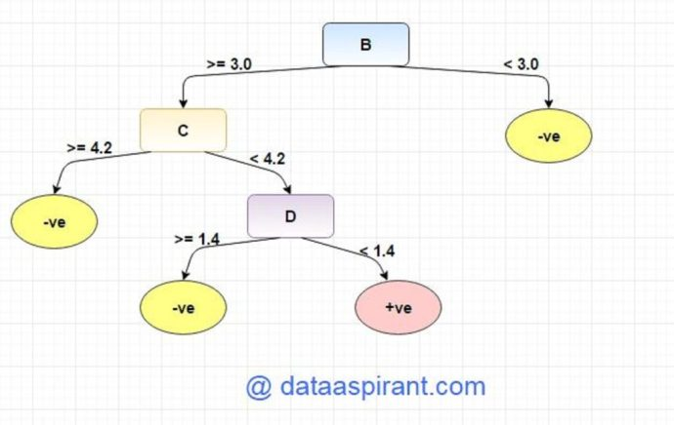

Gini Index
Gini Index is a metric to measure how often a randomly chosen element would be incorrectly identified. It means an attribute with lower gini index should be preferred.

Example: Construct a Decision Tree by using “gini index” as a criterion
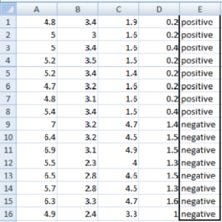
We are going to use same data sample that we used for information gain example. Let’s try to use gini index as a criterion. Here, we have 5 columns out of which 4 columns have continuous data and 5th column consists of class labels.
A, B, C, D attributes can be considered as predictors and E column class labels can be considered as a target variable. For constructing a decision tree from this data, we have to convert continuous data into categorical data.
We have chosen some random values to categorize each attribute:
A | B | C | D
>= 5 | >= 3.0 | >=4.2 | >= 1.4
< 5 | < 3.0 | < 4.2 | < 1.4

Gini Index for Var A
Var A has value >=5 for 12 records out of 16 and 4 records with value <5 value.
- For Var A >= 5 & class == positive: 5/12
- For Var A >= 5 & class == negative: 7/12
  - gini(5,7) = 1- ( (5/12)2 + (7/12)2 ) = 0.4860
- For Var A <5 & class == positive: 3/4
- For Var A <5 & class == negative: 1/4
  - gini(3,1) = 1- ( (3/4)2 + (1/4)2 ) = 0.375
By adding weight and sum each of the gini indices:

Gini Index for Var B
Var B has value >=3 for 12 records out of 16 and 4 records with value <5 value.
- For Var B >= 3 & class == positive: 8/12
- For Var B >= 3 & class == negative: 4/12
  - gini(8,4) = 1- ( (8/12)2 + (4/12)2 ) = 0.446
- For Var B <3 & class == positive: 0/4
- For Var B <3 & class == negative: 4/4
  - gin(0,4) = 1- ( (0/4)2 + (4/4)2 ) = 0

Gini Index for Var C
Var C has value >=4.2 for 6 records out of 16 and 10 records with value <4.2 value.
- For Var C >= 4.2 & class == positive: 0/6
- For Var C >= 4.2 & class == negative: 6/6
  - gini(0,6) = 1- ( (0/8)2 + (6/6)2 ) = 0
- For Var C < 4.2& class == positive: 8/10
- For Var C < 4.2 & class == negative: 2/10
  - gin(8,2) = 1- ( (8/10)2 + (2/10)2 ) = 0.32

Gini Index for Var D
Var D has value >=1.4 for 5 records out of 16 and 11 records with value <1.4 value.
- For Var D >= 1.4 & class == positive: 0/5
- For Var D >= 1.4 & class == negative: 5/5
  - gini(0,5) = 1- ( (0/5)2 + (5/5)2 ) = 0
- For Var D < 1.4 & class == positive: 8/11
- For Var D < 1.4 & class == negative: 3/11
  - gin(8,3) = 1- ( (8/11)2 + (3/11)2 ) = 0.397
Target |  |  |  |  |  |  | Target
 |  |  | Positive |  | Negative |  |  |  |  |  | Positive |  | Negative
A |  | >=5 | 5 |  | 7 |  | B |  |  | >=3 | 8 |  | 4
 |  | <5 | 3 |  | 1 |  |  |  |  | <3 | 0 |  | 4
Gini Index of A=0.45825 |  |  |  |  |  |  | Gini Index of B=0.3345
Target |  |  |  |  |  |  |  | Target
 |  |  |  | Positive |  | Negative |  |  |  |  |  | Positive |  | Negative
A | >=4.2 |  |  | 0 |  | 6 |  | B | >=1.4 |  |  | 0 |  | 5
 | <4.2 |  |  | 8 |  | 2 |  |  | <1.4 |  |  | 8 |  | 3
Gini Index of A=0.2 |  |  |  |  |  |  |  | Gini Index of B=0.273

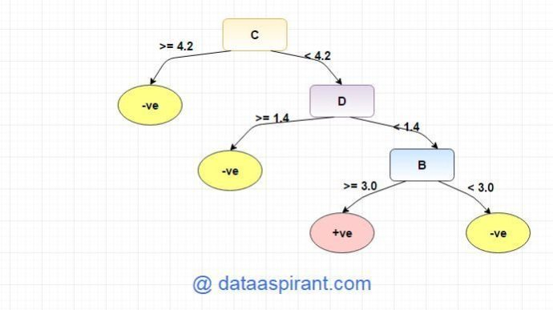

Overfitting
Overfitting is a practical problem while building a decision tree model. The model is having an issue of overfitting is considered when the algorithm continues to go deeper and deeper in the to reduce the training set error but results with an increased test set error i.e, Accuracy of prediction for our model goes down. It generally happens when it builds many branches due to outliers and irregularities in data.
Two approaches which we can use to avoid overfitting are:
- Pre-Pruning
- Post-Pruning

Pre-Pruning
In pre-pruning, it stops the tree construction bit early. It is preferred not to split a node if its goodness measure is below a threshold value. But it’s difficult to choose an appropriate stopping point.

Post-Pruning
In post-pruning first, it goes deeper and deeper in the tree to build a complete tree. If the tree shows the overfitting problem then pruning is done as a post-pruning step. We use a cross-validation data to check the effect of our pruning. Using cross-validation data, it tests whether expanding a node will make an improvement or not.
If it shows an improvement, then we can continue by expanding that node. But if it shows a reduction in accuracy then it should not be expanded i.e, the node should be converted to a leaf node.

Decision Tree Algorithm Advantages and Disadvantages

Advantages:
- Decision Trees are easy to explain. It results in a set of rules.
- It follows the same approach as humans generally follow while making decisions.
- Interpretation of a complex Decision Tree model can be simplified by its visualizations. Even a naive person can understand logic.
- The Number of hyper-parameters to be tuned is almost null.

Disadvantages:
- There is a high probability of over fitting in Decision Tree.
- Generally, it gives low prediction accuracy for a dataset as compared to other machine learning algorithms.
- Information gain in a decision tree with categorical variables gives a biased response for attributes with greater no. of categories.
- Calculations can become complex when there are many class labels.

Decision Tree Algorithm — Explained

https://towardsdatascience.com/decision-tree-algorithm-explained-83beb6e78ef4

All you need to know about Decision Trees and how to build and optimize Decision Tree Classifier.



Introduction
Classification is a two-step process, learning step and prediction step, in machine learning. In the learning step, the model is developed based on given training data. In the prediction step, the model is used to predict the response for given data. Decision Tree is one of the easiest and popular classification algorithms to understand and interpret.

Decision Tree Algorithm
Decision Tree algorithm belongs to the family of supervised learning algorithms. Unlike other supervised learning algorithms, the decision tree algorithm can be used for solving regression and classification problems too.
The goal of using a Decision Tree is to create a training model that can use to predict the class or value of the target variable by learning simple decision rules inferred from prior data(training data).
In Decision Trees, for predicting a class label for a record we start from the root of the tree. We compare the values of the root attribute with the record’s attribute. On the basis of comparison, we follow the branch corresponding to that value and jump to the next node.

Types of Decision Trees
Types of decision trees are based on the type of target variable we have. It can be of two types:
- Categorical Variable Decision Tree: Decision Tree which has a categorical target variable then it called a Categorical variable decision tree.
- Continuous Variable Decision Tree: Decision Tree has a continuous target variable then it is called Continuous Variable Decision Tree.
Example:- Let’s say we have a problem to predict whether a customer will pay his renewal premium with an insurance company (yes/ no). Here we know that the income of customers is a significant variable but the insurance company does not have income details for all customers. Now, as we know this is an important variable, then we can build a decision tree to predict customer income based on occupation, product, and various other variables. In this case, we are predicting values for the continuous variables.

Important Terminology related to Decision Trees
- Root Node: It represents the entire population or sample and this further gets divided into two or more homogeneous sets.
- Splitting: It is a process of dividing a node into two or more sub-nodes.
- Decision Node: When a sub-node splits into further sub-nodes, then it is called the decision node.
- Leaf / Terminal Node: Nodes do not split is called Leaf or Terminal node.
- Pruning: When we remove sub-nodes of a decision node, this process is called pruning. You can say the opposite process of splitting.
- Branch / Sub-Tree: A subsection of the entire tree is called branch or sub-tree.
- Parent and Child Node: A node, which is divided into sub-nodes is called a parent node of sub-nodes whereas sub-nodes are the child of a parent node.

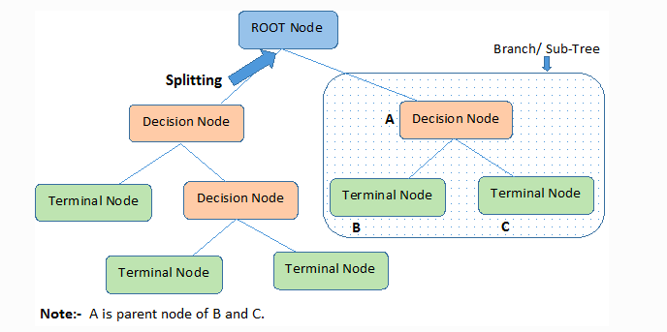
Decision trees classify the examples by sorting them down the tree from the root to some leaf/terminal node, with the leaf/terminal node providing the classification of the example.
Each node in the tree acts as a test case for some attribute, and each edge descending from the node corresponds to the possible answers to the test case. This process is recursive in nature and is repeated for every subtree rooted at the new node.

Assumptions while creating Decision Tree
Below are some of the assumptions we make while using Decision tree:
- In the beginning, the whole training set is considered as the root.
- Feature values are preferred to be categorical. If the values are continuous then they are discretized prior to building the model.
- Records are distributed recursively on the basis of attribute values.
- Order to placing attributes as root or internal node of the tree is done by using some statistical approach.
Decision Trees follow Sum of Product (SOP) representation. The Sum of product (SOP) is also known as Disjunctive Normal Form. For a class, every branch from the root of the tree to a leaf node having the same class is conjunction (product) of values, different branches ending in that class form a disjunction (sum).
The primary challenge in the decision tree implementation is to identify which attributes do we need to consider as the root node and each level. Handling this is to know as the attributes selection. We have different attributes selection measures to identify the attribute which can be considered as the root note at each level.

How do Decision Trees work?
The decision of making strategic splits heavily affects a tree’s accuracy. The decision criteria are different for classification and regression trees.
Decision trees use multiple algorithms to decide to split a node into two or more sub-nodes. The creation of sub-nodes increases the homogeneity of resultant sub-nodes. In other words, we can say that the purity of the node increases with respect to the target variable. The decision tree splits the nodes on all available variables and then selects the split which results in most homogeneous sub-nodes.
The algorithm selection is also based on the type of target variables. Let us look at some algorithms used in Decision Trees:
ID3 → (extension of D3)
C4.5 → (successor of ID3)
CART → (Classification And Regression Tree)
CHAID → (Chi-square automatic interaction detection Performs multi-level splits when computing classification trees)
MARS → (multivariate adaptive regression splines)
The ID3 algorithm builds decision trees using a top-down greedy search approach through the space of possible branches with no backtracking. A greedy algorithm, as the name suggests, always makes the choice that seems to be the best at that moment.
Steps in ID3 algorithm:
- It begins with the original set S as the root node.
- On each iteration of the algorithm, it iterates through the very unused attribute of the set S and calculates Entropy(H) and Information gain(IG) of this attribute.
- It then selects the attribute which has the smallest Entropy or Largest Information gain.
- The set S is then split by the selected attribute to produce a subset of the data.
- The algorithm continues to recur on each subset, considering only attributes never selected before.

Attribute Selection Measures
If the dataset consists of N attributes then deciding which attribute to place at the root or at different levels of the tree as internal nodes is a complicated step. By just randomly selecting any node to be the root can’t solve the issue. If we follow a random approach, it may give us bad results with low accuracy.
For solving this attribute selection problem, researchers worked and devised some solutions. They suggested using some criteria like :

Entropy,
Information gain,
Gini index,
Gain Ratio,
Reduction in Variance
Chi-Square
These criterions will calculate values for every attribute. The values are sorted, and attributes are placed in the tree by following the order i.e, the attribute with a high value(in case of information gain) is placed at the root.
While using Information Gain as a criterion, we assume attributes to be categorical, and for the Gini index, attributes are assumed to be continuous.

Entropy
Entropy is a measure of the randomness in the information being processed. The higher the entropy, the harder it is to draw any conclusions from that information. Flipping a coin is an example of an action that provides information that is random.

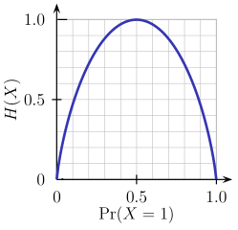
From the above graph, it is quite evident that the entropy H(X) is zero when the probability is either 0 or 1. The Entropy is maximum when the probability is 0.5 because it projects perfect randomness in the data and there is no chance if perfectly determining the outcome.
ID3 follows the rule — A branch with an entropy of zero is a leaf node and A brach with entropy more than zero needs further splitting.
Mathematically Entropy for 1 attribute is represented as:

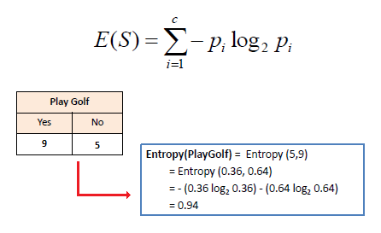
Where S → Current state, and Pi → Probability of an event i of state S or Percentage of class i in a node of state S.
Mathematically Entropy for multiple attributes is represented as:

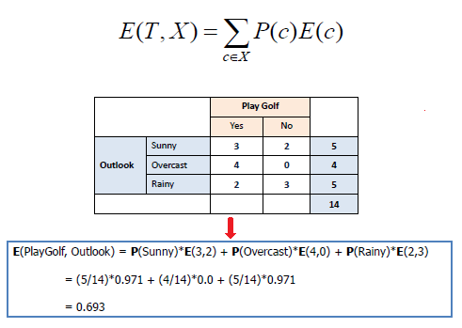
where T→ Current state and X → Selected attribute

Information Gain
Information gain or IG is a statistical property that measures how well a given attribute separates the training examples according to their target classification. Constructing a decision tree is all about finding an attribute that returns the highest information gain and the smallest entropy.

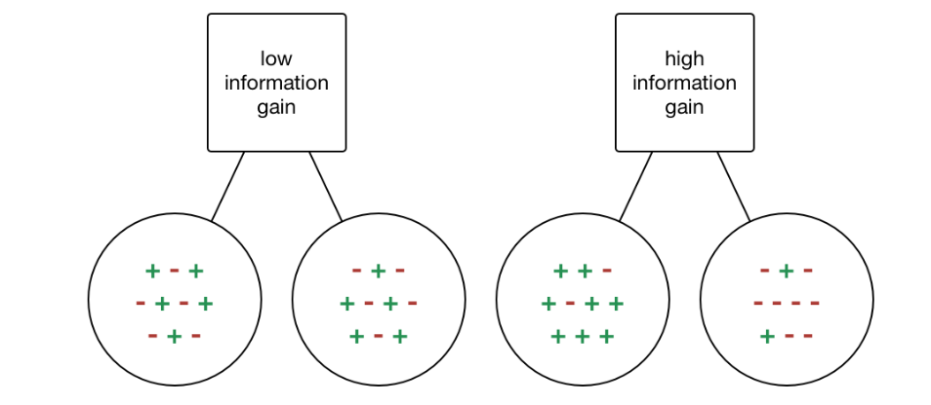

Information Gain
Information gain is a decrease in entropy. It computes the difference between entropy before split and average entropy after split of the dataset based on given attribute values. ID3 (Iterative Dichotomiser) decision tree algorithm uses information gain.
Mathematically, IG is represented as:

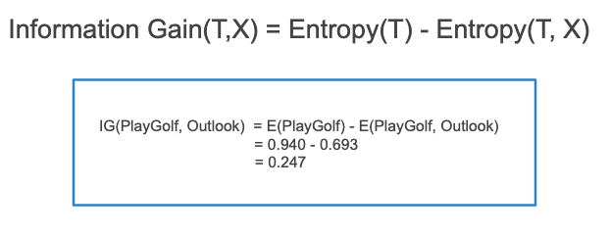
In a much simpler way, we can conclude that:

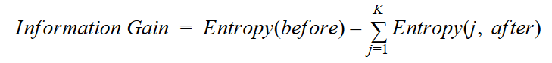
Where “before” is the dataset before the split, K is the number of subsets generated by the split, and (j, after) is subset j after the split.

Gini Index
You can understand the Gini index as a cost function used to evaluate splits in the dataset. It is calculated by subtracting the sum of the squared probabilities of each class from one. It favors larger partitions and easy to implement whereas information gain favors smaller partitions with distinct values.

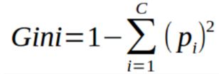
Gini Index works with the categorical target variable “Success” or “Failure”. It performs only Binary splits.
Higher the value of Gini index higher the homogeneity.
Steps to Calculate Gini index for a split
- Calculate Gini for sub-nodes, using the above formula for success(p) and failure(q) (p²+q²).
- Calculate the Gini index for split using the weighted Gini score of each node of that split.
CART (Classification and Regression Tree) uses the Gini index method to create split points.

Gain ratio
Information gain is biased towards choosing attributes with a large number of values as root nodes. It means it prefers the attribute with a large number of distinct values.
C4.5, an improvement of ID3, uses Gain ratio which is a modification of Information gain that reduces its bias and is usually the best option. Gain ratio overcomes the problem with information gain by taking into account the number of branches that would result before making the split. It corrects information gain by taking the intrinsic information of a split into account.
Let us consider if we have a dataset that has users and their movie genre preferences based on variables like gender, group of age, rating, blah, blah. With the help of information gain, you split at ‘Gender’ (assuming it has the highest information gain) and now the variables ‘Group of Age’ and ‘Rating’ could be equally important and with the help of gain ratio, it will penalize a variable with more distinct values which will help us decide the split at the next level.

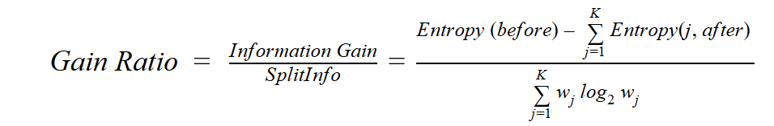
Where “before” is the dataset before the split, K is the number of subsets generated by the split, and (j, after) is subset j after the split.

Reduction in Variance
Reduction in variance is an algorithm used for continuous target variables (regression problems). This algorithm uses the standard formula of variance to choose the best split. The split with lower variance is selected as the criteria to split the population:

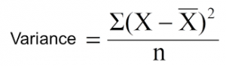
Above X-bar is the mean of the values, X is actual and n is the number of values.
Steps to calculate Variance:
- Calculate variance for each node.
- Calculate variance for each split as the weighted average of each node variance.

Chi-Square
The acronym CHAID stands for Chi-squared Automatic Interaction Detector. It is one of the oldest tree classification methods. It finds out the statistical significance between the differences between sub-nodes and parent node. We measure it by the sum of squares of standardized differences between observed and expected frequencies of the target variable.
It works with the categorical target variable “Success” or “Failure”. It can perform two or more splits. Higher the value of Chi-Square higher the statistical significance of differences between sub-node and Parent node.
It generates a tree called CHAID (Chi-square Automatic Interaction Detector).
Mathematically, Chi-squared is represented as:

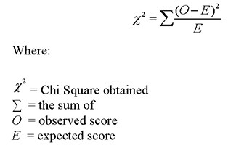
Steps to Calculate Chi-square for a split:
- Calculate Chi-square for an individual node by calculating the deviation for Success and Failure both
- Calculated Chi-square of Split using Sum of all Chi-square of success and Failure of each node of the split

How to avoid/counter Overfitting in Decision Trees?
The common problem with Decision trees, especially having a table full of columns, they fit a lot. Sometimes it looks like the tree memorized the training data set. If there is no limit set on a decision tree, it will give you 100% accuracy on the training data set because in the worse case it will end up making 1 leaf for each observation. Thus this affects the accuracy when predicting samples that are not part of the training set.
Here are two ways to remove overfitting:
- Pruning Decision Trees.
- Random Forest
Pruning Decision Trees
The splitting process results in fully grown trees until the stopping criteria are reached. But, the fully grown tree is likely to overfit the data, leading to poor accuracy on unseen data.


Pruning in action
In pruning, you trim off the branches of the tree, i.e., remove the decision nodes starting from the leaf node such that the overall accuracy is not disturbed. This is done by segregating the actual training set into two sets: training data set, D and validation data set, V. Prepare the decision tree using the segregated training data set, D. Then continue trimming the tree accordingly to optimize the accuracy of the validation data set, V.

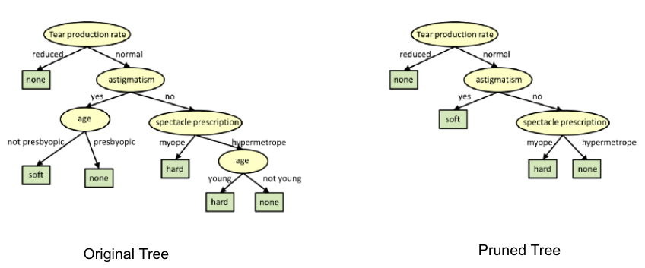
In the above diagram, the ‘Age’ attribute in the left-hand side of the tree has been pruned as it has more importance on the right-hand side of the tree, hence removing overfitting.
Random Forest
Random Forest is an example of ensemble learning, in which we combine multiple machine learning algorithms to obtain better predictive performance.
Why the name “Random”?
Two key concepts that give it the name random:
- A random sampling of training data set when building trees.
- Random subsets of features considered when splitting nodes.
A technique known as bagging is used to create an ensemble of trees where multiple training sets are generated with replacement.
In the bagging technique, a data set is divided into N samples using randomized sampling. Then, using a single learning algorithm a model is built on all samples. Later, the resultant predictions are combined using voting or averaging in parallel.


Random Forest in action

Which is better Linear or tree-based models?
Well, it depends on the kind of problem you are solving.
- If the relationship between dependent & independent variables is well approximated by a linear model, linear regression will outperform the tree-based model.
- If there is a high non-linearity & complex relationship between dependent & independent variables, a tree model will outperform a classical regression method.
- If you need to build a model that is easy to explain to people, a decision tree model will always do better than a linear model. Decision tree models are even simpler to interpret than linear regression!

Decision Tree Classifier Building in Scikit-learn
The dataset that we have is a supermarket data which can be downloaded from here.
Load all the basic libraries.

import numpy as np
import matplotlib.pyplot as plt
import pandas as pd
Load the dataset. It consists of 5 features, UserID, Gender, Age, EstimatedSalary and Purchased.
data = pd.read_csv('/Users/ML/DecisionTree/Social.csv')
data.head()

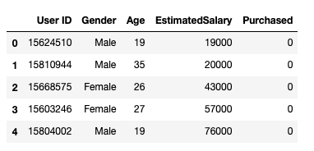
Dataset
We will take only Age and EstimatedSalary as our independent variables X because of other features like Gender and User ID are irrelevant and have no effect on the purchasing capacity of a person. Purchased is our dependent variable y.

feature_cols = ['Age','EstimatedSalary' ]X = data.iloc[:,[2,3]].values
y = data.iloc[:,4].values
The next step is to split the dataset into training and test.
from sklearn.model_selection import train_test_split
X_train, X_test, y_train, y_test = train_test_split(X,y,test_size = 0.25, random_state= 0)
Perform feature scaling
#feature scaling
from sklearn.preprocessing import StandardScaler
sc_X = StandardScaler()
X_train = sc_X.fit_transform(X_train)
X_test = sc_X.transform(X_test)
Fit the model in the Decision Tree classifier.
from sklearn.tree import DecisionTreeClassifier
classifier = DecisionTreeClassifier()
classifier = classifier.fit(X_train,y_train)
Make predictions and check accuracy.
#prediction
y_pred = classifier.predict(X_test)#Accuracy
from sklearn import metricsprint('Accuracy Score:', metrics.accuracy_score(y_test,y_pred))
The decision tree classifier gave an accuracy of 91%.
Confusion Matrix
from sklearn.metrics import confusion_matrix
cm = confusion_matrix(y_test, y_pred)Output:
array([[64, 4],
[ 2, 30]])
It means 6 observations have been classified as false.
Let us first visualize the model prediction results.
from matplotlib.colors import ListedColormap
X_set, y_set = X_test, y_test
X1, X2 = np.meshgrid(
np.arange(start=X_set[:,0].min()-1,
stop=X_set[:,0].max()+1,step=0.01),
np.arange(start = X_set[:,1].min()-1,
stop= X_set[:,1].max()+1, step = 0.01)
)
plt.contourf(X1,X2, classifier.predict(np.array([X1.ravel(), X2.ravel()]).T).reshape(X1.shape), alpha=0.75, cmap = ListedColormap(("red","green")))plt.xlim(X1.min(), X1.max())
plt.ylim(X2.min(), X2.max())for i,j in enumerate(np.unique(y_set)):
plt.scatter(X_set[y_set==j,0],X_set[y_set==j,1], c = ListedColormap(("red","green"))(i),label = j)
plt.title("Decision Tree(Test set)")
plt.xlabel("Age")
plt.ylabel("Estimated Salary")
plt.legend()
plt.show()

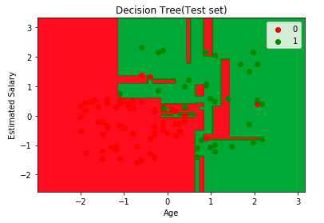
Let us also visualize the tree:
You can use Scikit-learn’s export_graphviz function to display the tree within a Jupyter notebook. For plotting trees, you also need to install Graphviz and pydotplus.

conda install python-graphviz
pip install pydotplus
export_graphviz function converts decision tree classifier into dot file and pydotplus convert this dot file to png or displayable form on Jupyter.
from sklearn.tree import export_graphviz
from sklearn.externals.six import StringIO
from IPython.display import Image
import pydotplusdot_data = StringIO()
export_graphviz(classifier, out_file=dot_data,
filled=True, rounded=True,
special_characters=True,feature_names = feature_cols,class_names=['0','1'])
graph = pydotplus.graph_from_dot_data(dot_data.getvalue())
Image(graph.create_png())

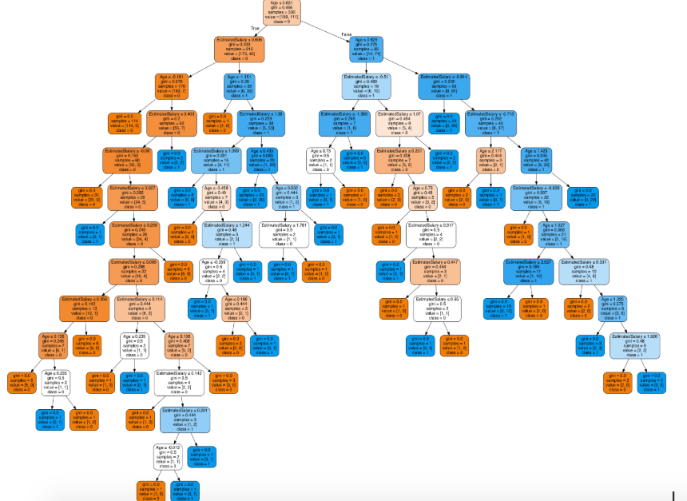
Decision Tree.
In the decision tree chart, each internal node has a decision rule that splits the data. Gini referred to as the Gini ratio, which measures the impurity of the node. You can say a node is pure when all of its records belong to the same class, such nodes known as the leaf node.
Here, the resultant tree is unpruned. This unpruned tree is unexplainable and not easy to understand. In the next section, let’s optimize it by pruning.
Optimizing the Decision Tree Classifier
criterion: optional (default=”gini”) or Choose attribute selection measure: This parameter allows us to use the different-different attribute selection measure. Supported criteria are “gini” for the Gini index and “entropy” for the information gain.
splitter: string, optional (default=”best”) or Split Strategy: This parameter allows us to choose the split strategy. Supported strategies are “best” to choose the best split and “random” to choose the best random split.
max_depth: int or None, optional (default=None) or Maximum Depth of a Tree: The maximum depth of the tree. If None, then nodes are expanded until all the leaves contain less than min_samples_split samples. The higher value of maximum depth causes overfitting, and a lower value causes underfitting (Source).
In Scikit-learn, optimization of decision tree classifier performed by only pre-pruning. The maximum depth of the tree can be used as a control variable for pre-pruning.

# Create Decision Tree classifer object
classifier = DecisionTreeClassifier(criterion="entropy", max_depth=3)# Train Decision Tree Classifer
classifier = classifier.fit(X_train,y_train)#Predict the response for test dataset
y_pred = classifier.predict(X_test)# Model Accuracy, how often is the classifier correct?
print("Accuracy:",metrics.accuracy_score(y_test, y_pred))
Well, the classification rate increased to 94%, which is better accuracy than the previous model.
Now let us again visualize the pruned Decision tree after optimization.
dot_data = StringIO()
export_graphviz(classifier, out_file=dot_data,
filled=True, rounded=True,
special_characters=True, feature_names = feature_cols,class_names=['0','1'])
graph = pydotplus.graph_from_dot_data(dot_data.getvalue())
Image(graph.create_png())

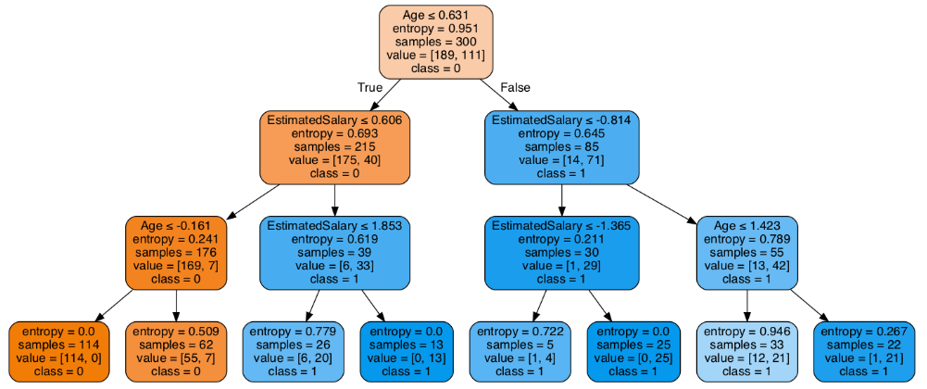
Decision Tree after pruning
This pruned model is less complex, explainable, and easy to understand than the previous decision tree model plot.

Conclusion
In this article, we have covered a lot of details about Decision Tree; It’s working, attribute selection measures such as Information Gain, Gain Ratio, and Gini Index, decision tree model building, visualization and evaluation on supermarket dataset using Python Scikit-learn package and optimizing Decision Tree performance using parameter tuning.
Well, that’s all for this article hope you guys have enjoyed reading it, feel free to share your comments/thoughts/feedback in the comment section.



Decision Trees Algorithms

Source: https://medium.com/deep-math-machine-learning-ai/chapter-4-decision-trees-algorithms-b93975f7a1f1
Decision tree is one of the most popular machine learning algorithms used all along, This story I wanna talk about it so let’s get started!!!
Decision trees are used for both classification and regression problems, this story we talk about classification.
Before we dive into it , let me ask you this
Why Decision trees?
We have couple of other algorithms there, so why do we have to choose Decision trees??
well, there might be many reasons but I believe a few which are
- Decision tress often mimic the human level thinking so its so simple to understand the data and make some good interpretations.
- Decision trees actually make you see the logic for the data to interpret(not like black box algorithms like SVM,NN,etc..)

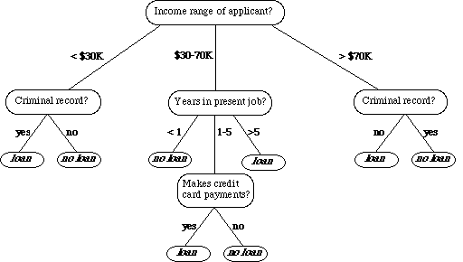
For example : if we are classifying bank loan application for a customer, the decision tree may look like this
Here we can see the logic how it is making the decision.
It’s simple and clear.

So what is the decision tree??
A decision tree is a tree where each node represents a feature (attribute), each link (branch) represents a decision(rule) and each leaf represents an outcome(categorical or continues value).
The whole idea is to create a tree like this for the entire data and process a single outcome at every leaf (or minimize the error in every leaf).

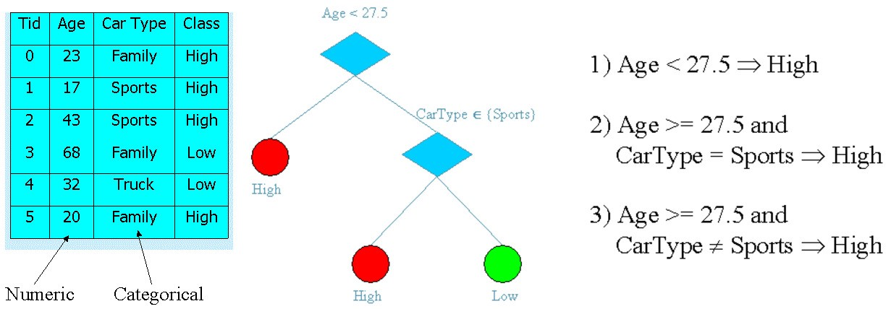
Okay so how to build this??
There are couple of algorithms there to build a decision tree , we only talk about a few which are
- CART (Classification and Regression Trees) → uses Gini Index(Classification) as metric.
- ID3 (Iterative Dichotomiser 3) → uses Entropy function and Information gain as metrics.
Lets just first build decision tree for classification problem using above algorithms,
Classification with using the ID3 algorithm.
Let’s just take a famous dataset in the machine learning world which is weather dataset(playing game Y or N based on weather condition).

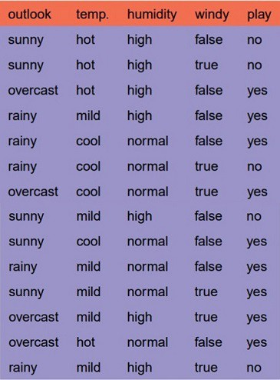
We have four X values (outlook, temp, humidity and windy) being categorical and one y value (play Y or N) also being categorical.
So we need to learn the mapping (what machine learning always does) between X and y.
This is a binary classification problem, let’s build the tree using the ID3 algorithm
To create a tree, we need to have a root node first and we know that nodes are features/attributes (outlook, temp, humidity and windy),
So which one do we need to pick first??
Answer: determine the attribute that best classifies the training data; use this attribute at the root of the tree. Repeat this process at for each branch.
This means we are performing top-down, greedy search through the space of possible decision trees.
Okay so how do we choose the best attribute?
Answer: use the attribute with the highest information gain in ID3
In order to define information gain precisely, we begin by defining a measure commonly used in information theory, called entropy that characterizes the (im)purity of an arbitrary collection of examples.”

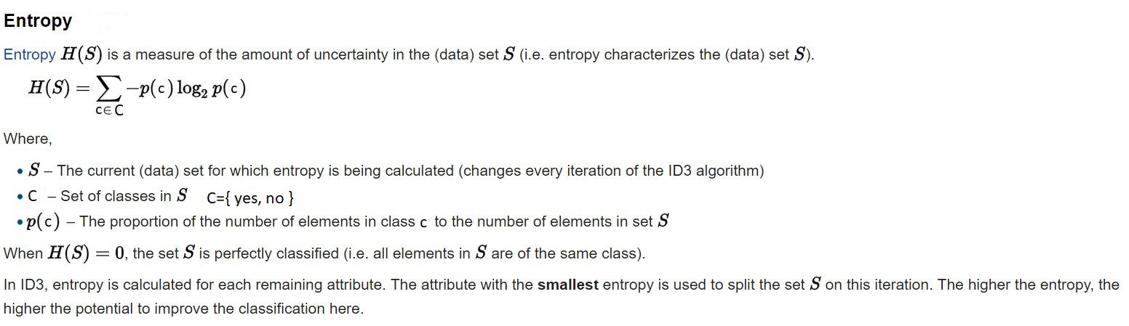
wikipedia
For a binary classification problem
- If all examples are positive or all are negative then entropy will be zero i.e, low.
- If half of the examples are of positive class and half are of negative class then entropy is one i.e, high.

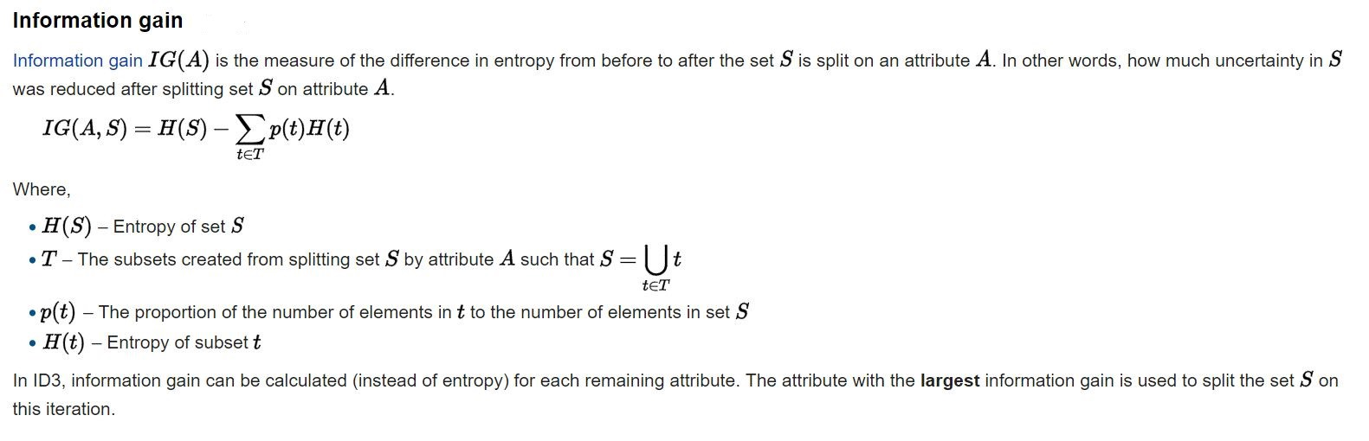
wikipedia
Okay lets apply these metrics to our dataset to split the data(getting the root node)
Steps:
1. Compute the entropy for data-set
2. for every attribute/feature:
1.calculate entropy for all categorical values
2.take average information entropy for the current attribute
3.calculate gain for the current attribute
3. Pick the highest gain attribute.
4. Repeat until we get the tree we desired.

What the heck???
Okay I got it, if it does not make sense to you , let me make it sense to you.
Compute the entropy for the weather data set:

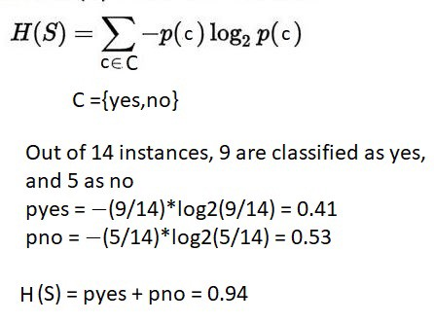
For every feature calculate the entropy and information gain

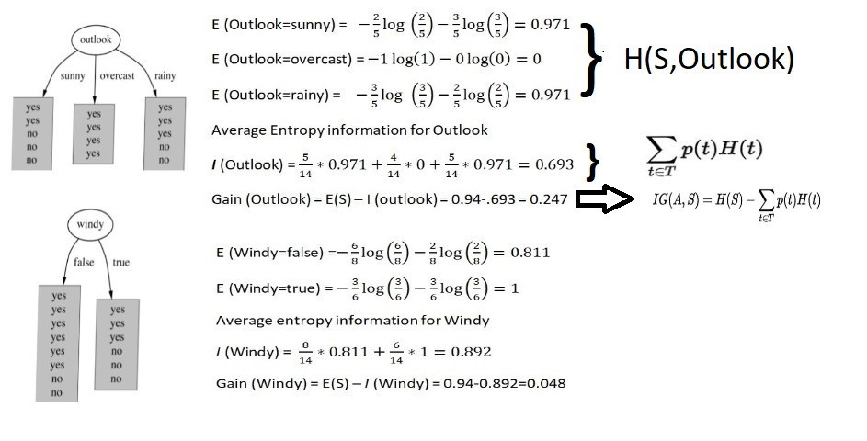
Similarity we can calculate for other two attributes(Humidity and Temp).
Pick the highest gain attribute.

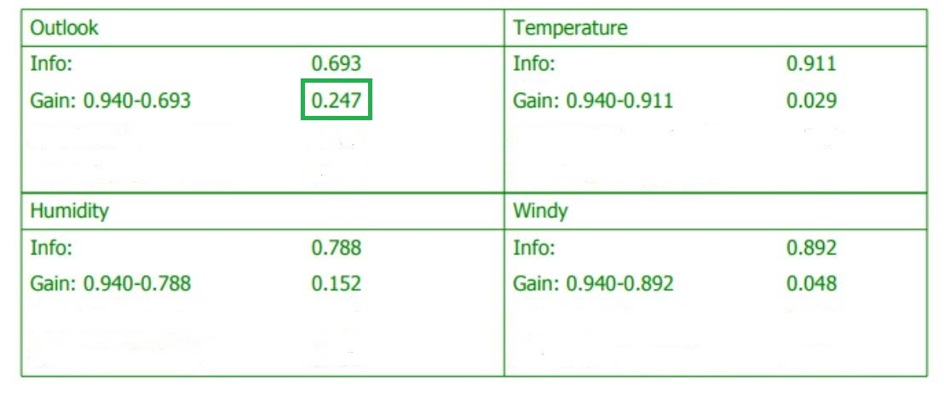
So our root node is Outlook.

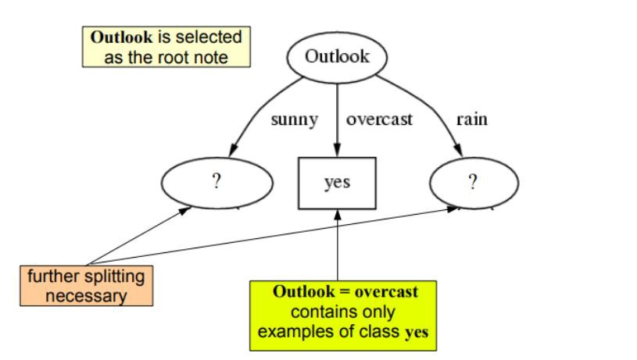
Repeat the same thing for sub-trees till we get the tree.

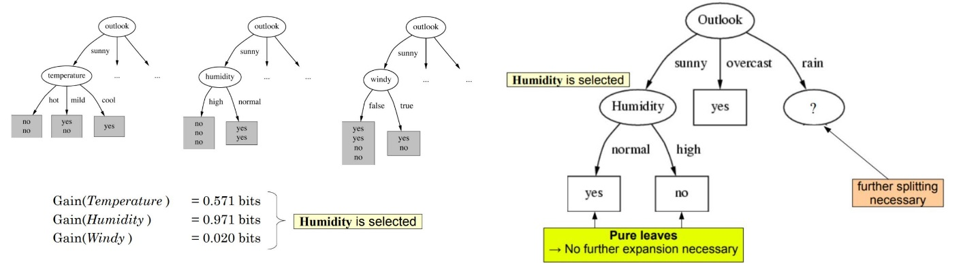
Finally we get the tree something like his.

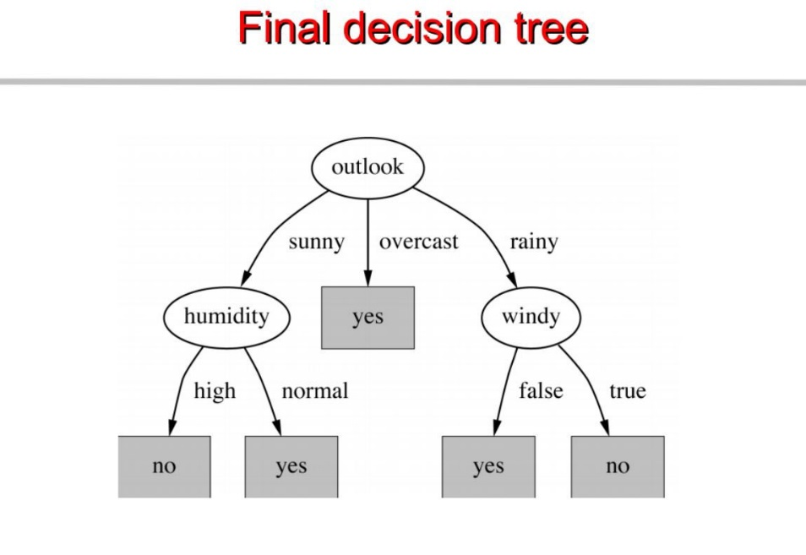
Classification with using the CART algorithm.
In CART we use Gini index as a metric,
We use the Gini Index as our cost function used to evaluate splits in the dataset.
our target variable is Binary variable which means it take two values (Yes and No). There can be 4 combinations.

Actual=1 predicted 1
1 0 , 0,1, 0 0P(Target=1).P(Target=1) + P(Target=1).P(Target=0) + P(Target=0).P(Target=1) + P(Target=0).P(Target=0) = 1P(Target=1).P(Target=0) + P(Target=0).P(Target=1) = 1 — P^2(Target=0) — P^2(Target=1)

Gini Index for Binary Target variable is
= 1 — P^2(Target=0) — P^2(Target=1)

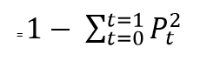
Gini index
A Gini score gives an idea of how good a split is by how mixed the classes are in the two groups created by the split. A perfect separation results in a Gini score of 0, whereas the worst case split that results in 50/50 classes.
We calculate it for every row and split the data accordingly in our binary tree. We repeat this process recursively.
For Binary Target variable, Max Gini Index value
= 1 — (1/2)^2 — (1/2)^2
= 1–2*(1/2)^2
= 1- 2*(1/4)
= 1–0.5
= 0.5
Similarly if Target Variable is categorical variable with multiple levels, the Gini Index will be still similar. If Target variable takes k different values, the Gini Index will be

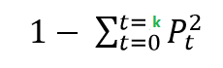
Maximum value of Gini Index could be when all target values are equally distributed.
Similarly for Nominal variable with k level, the maximum value Gini Index is
= 1–1/k
Minimum value of Gini Index will be 0 when all observations belong to one label.
Steps:
1. Compute the gini index for data-set
2. for every attribute/feature:
1.calculate gini index for all categorical values
2.take average information entropy for the current attribute
3.calculate the gini gain
3. Pick the best gini gain attribute.
4. Repeat until we get the tree we desired.
The calculations are similar to ID3 , except the formula changes.
For example: compute gini index for dataset

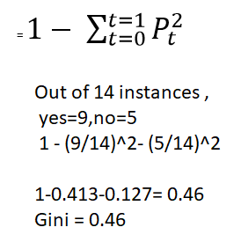
Similarly we can follow other steps to build the tree

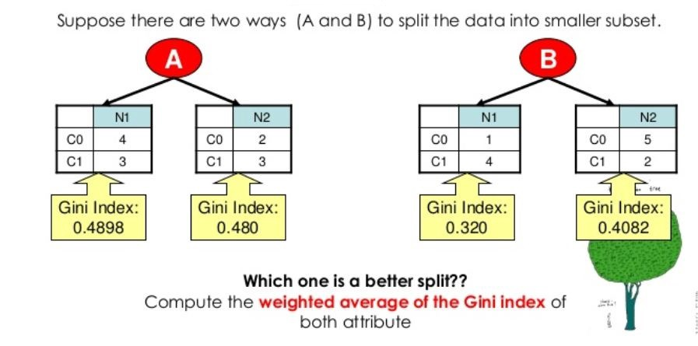
That’s it for this story. hope you enjoyed and learned something.
Let me know your thoughts/suggestions/questions.
we just talked the first half of Decision trees , we can talk about the other half later (some statistical notations, theories and algorithms)
In the next story we will code this algorithm from scratch (without using any ML libraries).
Until then
See ya!
The images I borrowed from a pdf book which I am not sure and don’t have link to add it. Let me know if anyone finds the abouve diagrams in a pdf book so I can link it.

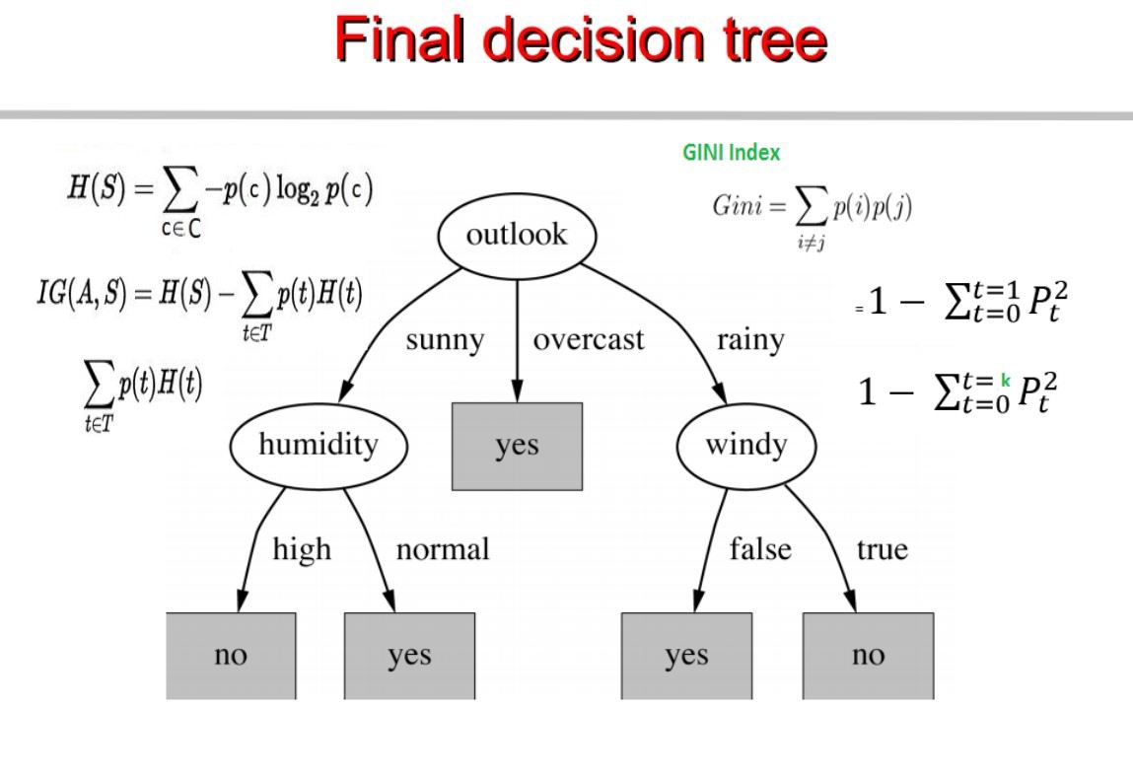

Decision Tree in Machine Learning

Source: https://towardsdatascience.com/decision-tree-in-machine-learning-e380942a4c96


A decision tree is a flowchart-like structure in which each internal node represents a test on a feature (e.g. whether a coin flip comes up heads or tails) , each leaf node represents a class label (decision taken after computing all features) and branches represent conjunctions of features that lead to those class labels. The paths from root to leaf represent classification rules. Below diagram illustrate the basic flow of decision tree for decision making with labels (Rain(Yes), No Rain(No)).

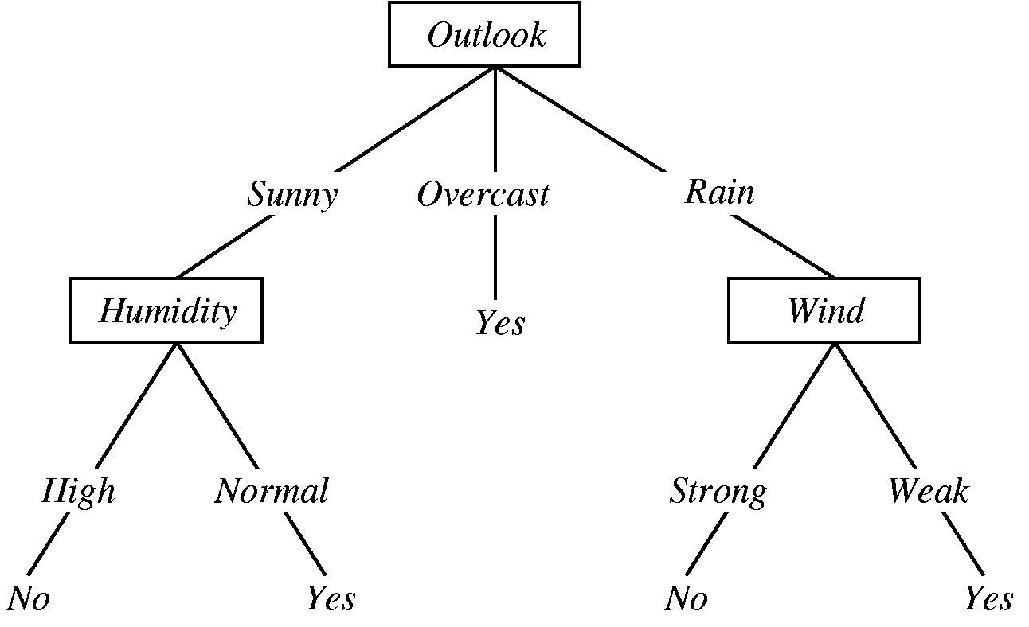
Decision Tree for Rain Forecasting
Decision tree is one of the predictive modelling approaches used in statistics, data mining and machine learning.
Decision trees are constructed via an algorithmic approach that identifies ways to split a data set based on different conditions. It is one of the most widely used and practical methods for supervised learning. Decision Trees are a non-parametric supervised learning method used for both classification and regression tasks.
Tree models where the target variable can take a discrete set of values are called classification trees. Decision trees where the target variable can take continuous values (typically real numbers) are called regression trees. Classification And Regression Tree (CART) is general term for this.
Throughout this post i will try to explain using the examples.

Data Format
Data comes in records of forms.
(x,Y)=(x1,x2,x3,....,xk,Y)
The dependent variable, Y, is the target variable that we are trying to understand, classify or generalize. The vector x is composed of the features, x1, x2, x3 etc., that are used for that task.
Example
training_data = [
['Green', 3, 'Apple'],
['Yellow', 3, 'Apple'],
['Red', 1, 'Grape'],
['Red', 1, 'Grape'],
['Yellow', 3, 'Lemon'],
]
# Header = ["Color", "diameter", "Label"]
# The last column is the label.
# The first two columns are features.

Approach to make decision tree
While making decision tree, at each node of tree we ask different type of questions. Based on the asked question we will calculate the information gain corresponding to it.

Information Gain
Information gain is used to decide which feature to split on at each step in building the tree. Simplicity is best, so we want to keep our tree small. To do so, at each step we should choose the split that results in the purest daughter nodes. A commonly used measure of purity is called information. For each node of the tree, the information value measures how much information a feature gives us about the class. The split with the highest information gain will be taken as the first split and the process will continue until all children nodes are pure, or until the information gain is 0.

Asking Question
class Question:
"""A Question is used to partition a dataset. This class just records a 'column number' (e.g., 0 for Color) and a
'column value' (e.g., Green). The 'match' method is used to compare
the feature value in an example to the feature value stored in the
question. See the demo below.
""" def __init__(self, column, value):
self.column = column
self.value = value def match(self, example):
# Compare the feature value in an example to the
# feature value in this question.
val = example[self.column]
if is_numeric(val):
return val >= self.value
else:
return val == self.value def __repr__(self):
# This is just a helper method to print
# the question in a readable format.
condition = "=="
if is_numeric(self.value):
condition = ">="
return "Is %s %s %s?" % (
header[self.column], condition, str(self.value))
Lets try querying questions and its outputs.
Question(1, 3) ## Is diameter >= 3?
Question(0, "Green") ## Is color == Green?
Now we will try to Partition the dataset based on asked question. Data will be divided into two classes at each steps.
def partition(rows, question):
"""Partitions a dataset. For each row in the dataset, check if it matches the question. If
so, add it to 'true rows', otherwise, add it to 'false rows'.
"""
true_rows, false_rows = [], []
for row in rows:
if question.match(row):
true_rows.append(row)
else:
false_rows.append(row)
return true_rows, false_rows
# Let's partition the training data based on whether rows are Red.
true_rows, false_rows = partition(training_data, Question(0, 'Red'))
# This will contain all the 'Red' rows.
true_rows ## [['Red', 1, 'Grape'], ['Red', 1, 'Grape']]
false_rows ## [['Green', 3, 'Apple'], ['Yellow', 3, 'Apple'], ['Yellow', 3, 'Lemon']]
Algorithm for constructing decision tree usually works top-down, by choosing a variable at each step that best splits the set of items. Different algorithms use different metrices for measuring best.

Gini Impurity
First let’s understand the meaning of Pure and Impure.

Pure
Pure means, in a selected sample of dataset all data belongs to same class (PURE).

Impure
Impure means, data is mixture of different classes.

Definition of Gini Impurity
Gini Impurity is a measurement of the likelihood of an incorrect classification of a new instance of a random variable, if that new instance were randomly classified according to the distribution of class labels from the data set.
If our dataset is Pure then likelihood of incorrect classification is 0. If our sample is mixture of different classes then likelihood of incorrect classification will be high.
Calculating Gini Impurity.
def gini(rows):
"""Calculate the Gini Impurity for a list of rows.
There are a few different ways to do this, I thought this one was
the most concise. See:
https://en.wikipedia.org/wiki/Decision_tree_learning#Gini_impurity
"""
counts = class_counts(rows)
impurity = 1
for lbl in counts:
prob_of_lbl = counts[lbl] / float(len(rows))
impurity -= prob_of_lbl**2
return impurity
Example
# Demo 1:
# Let's look at some example to understand how Gini Impurity works.
#
# First, we'll look at a dataset with no mixing.
no_mixing = [['Apple'],
['Apple']]
# this will return 0
gini(no_mixing) ## output=0
## Demo 2:
# Now, we'll look at dataset with a 50:50 apples:oranges ratio
some_mixing = [['Apple'],
['Orange']]
# this will return 0.5 - meaning, there's a 50% chance of misclassifying
# a random example we draw from the dataset.
gini(some_mixing) ##output=0.5
## Demo 3:
# Now, we'll look at a dataset with many different labels
lots_of_mixing = [['Apple'],
['Orange'],
['Grape'],
['Grapefruit'],
['Blueberry']]
# This will return 0.8
gini(lots_of_mixing) ##output=0.8
#######

Steps for making decision tree
- Get list of rows (dataset) which are taken into consideration for making decision tree (recursively at each nodes).
- Calculate uncertainty of our dataset or Gini impurity or how much our data is mixed up etc.
- Generate list of all question which needs to be asked at that node.
- Partition rows into True rows and false rows based on each question asked.
- Calculate information gain based on gini impurity and partition of data from previous step.
- Update highest information gain based on each question asked.
- Update best question based on information gain (higher information gain).
- Divide the node on best question. Repeat again from step 1 again until we get pure node (leaf nodes).
Code for Above Steps
def find_best_split(rows):
"""Find the best question to ask by iterating over every feature / value
and calculating the information gain."""
best_gain = 0 # keep track of the best information gain
best_question = None # keep train of the feature / value that produced it
current_uncertainty = gini(rows)
n_features = len(rows[0]) - 1 # number of columns for col in range(n_features): # for each feature values = set([row[col] for row in rows]) # unique values in the column for val in values: # for each value question = Question(col, val) # try splitting the dataset
true_rows, false_rows = partition(rows, question) # Skip this split if it doesn't divide the
# dataset.
if len(true_rows) == 0 or len(false_rows) == 0:
continue # Calculate the information gain from this split
gain = info_gain(true_rows, false_rows, current_uncertainty) # You actually can use '>' instead of '>=' here
# but I wanted the tree to look a certain way for our
# toy dataset.
if gain >= best_gain:
best_gain, best_question = gain, question return best_gain, best_question
#######
# Demo:
# Find the best question to ask first for our toy dataset.
best_gain, best_question = find_best_split(training_data)
best_question
## output - Is diameter >= 3?
Now build the Decision tree based on step discussed above recursively at each node.
def build_tree(rows):
"""Builds the tree. Rules of recursion: 1) Believe that it works. 2) Start by checking
for the base case (no further information gain). 3) Prepare for
giant stack traces.
""" # Try partitioning the dataset on each of the unique attribute,
# calculate the information gain,
# and return the question that produces the highest gain.
gain, question = find_best_split(rows) # Base case: no further info gain
# Since we can ask no further questions,
# we'll return a leaf.
if gain == 0:
return Leaf(rows) # If we reach here, we have found a useful feature / value
# to partition on.
true_rows, false_rows = partition(rows, question) # Recursively build the true branch.
true_branch = build_tree(true_rows) # Recursively build the false branch.
false_branch = build_tree(false_rows) # Return a Question node.
# This records the best feature / value to ask at this point,
# as well as the branches to follow
# dependingo on the answer.
return Decision_Node(question, true_branch, false_branch)

Building Decision Tree
Let’s build decision tree based on training data.
training_data = [
['Green', 3, 'Apple'],
['Yellow', 3, 'Apple'],
['Red', 1, 'Grape'],
['Red', 1, 'Grape'],
['Yellow', 3, 'Lemon'],
]
# Header = ["Color", "diameter", "Label"]
# The last column is the label.
# The first two columns are features.
my_tree = build_tree(training_data)
print_tree(my_tree)
Output
Is diameter >= 3?
--> True:
Is color == Yellow?
--> True:
Predict {'Lemon': 1, 'Apple': 1}
--> False:
Predict {'Apple': 1}
--> False:
Predict {'Grape': 2}
From above output we can see that at each steps data is divided into True and False rows. This process keep repeated until we reach leaf node where information gain is 0 and further split of data is not possible as nodes are Pure.
Advantage of Decision Tree
- Easy to use and understand.
- Can handle both categorical and numerical data.
- Resistant to outliers, hence require little data preprocessing.
Disadvantage of Decision Tree
- Prone to overfitting.
- Require some kind of measurement as to how well they are doing.
- Need to be careful with parameter tuning.
- Can create biased learned trees if some classes dominate.

How to avoid over fitting the Decision tree model
Over fitting is one of the major problem for every model in machine learning. If model is over fitted it will poorly generalized to new samples. To avoid decision tree from over fitting we remove the branches that make use of features having low importance. This method is called as Pruning or post-pruning. This way we will reduce the complexity of tree, and hence improves predictive accuracy by the reduction of over fitting.
Pruning should reduce the size of a learning tree without reducing predictive accuracy as measured by a cross-validation set. There are 2 major Pruning techniques.
- Minimum Error: The tree is pruned back to the point where the cross-validated error is a minimum.
- Smallest Tree: The tree is pruned back slightly further than the minimum error. Technically the pruning creates a decision tree with cross-validation error within 1 standard error of the minimum error.

Early Stop or Pre-pruning
An alternative method to prevent overfitting is to try and stop the tree-building process early, before it produces leaves with very small samples. This heuristic is known as early stopping but is also sometimes known as pre-pruning decision trees.
At each stage of splitting the tree, we check the cross-validation error. If the error does not decrease significantly enough then we stop. Early stopping may underfit by stopping too early. The current split may be of little benefit, but having made it, subsequent splits more significantly reduce the error.
Early stopping and pruning can be used together, separately, or not at all. Post pruning decision trees is more mathematically rigorous, finding a tree at least as good as early stopping. Early stopping is a quick fix heuristic. If used together with pruning, early stopping may save time. After all, why build a tree only to prune it back again?

Decision Tree in Real Life
- Selecting a flight to travel
Suppose you need to select a flight for your next travel. How do we go about it? We check first if the flight is available on that day or not. If it is not available, we will look for some other date but if it is available then we look for may be the duration of the flight. If we want to have only direct flights then we look whether the price of that flight is in your pre-defined budget or not. If it is too expensive, we look at some other flights else we book it!
- Handling late night cravings

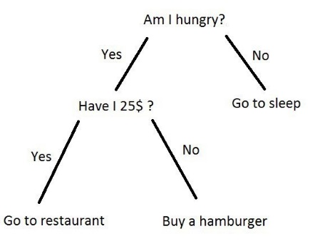
Source: Google
There are many more application of decision tree in real life. You can check this and this for more applications of decision tree.
From this article i tried to explain basics of decision tree and how basically it works. You can find the source code used in this article at github.

